How to add your signature in MS Outlook (Classic)
- Open a new email message.
- On the Message menu, select Signature > Signatures.
Depending on the size of your classic Outlook window and whether you're composing a new email message or a reply or forward, the Message menu and the Signature button might be in two different locations.
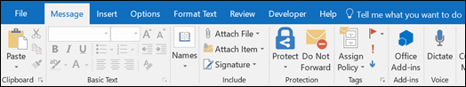
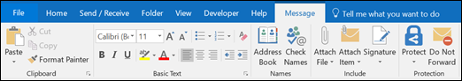
- Under Select signature to edit, choose New, and in the New Signature dialog box, type a name for the signature.
- Under Edit signature, compose your signature. Copy and paste the signature you would like to use from the Imperial Dade Email Signature Template file shared with you into the Edit signature box. Please note that the signatures have a specific format so be sure to follow the guidelines written in the document for font type/size, and logo placement/size. Update the signature with your own information.
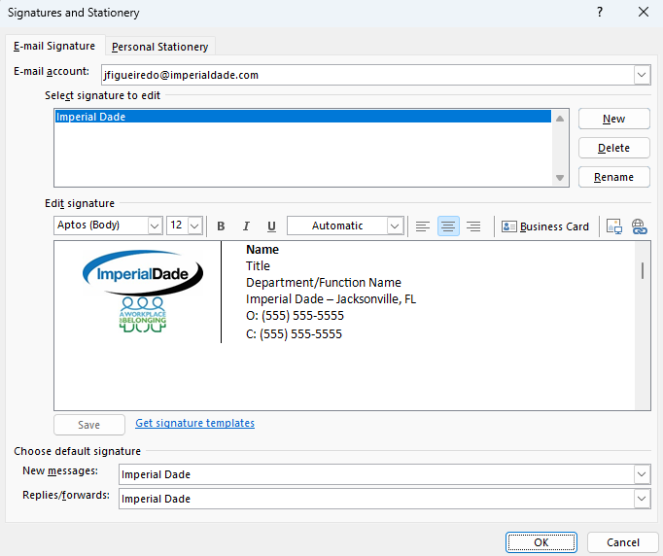
- Choose that signature as your default signature for new messages and replies/forwards (optional).
- Choose OK to save your new signature and return to your message. Classic Outlook doesn't add your new signature to the message you opened in Step 1, even if you chose to apply the signature to all new messages. You'll have to add the signature manually to this one message. All future messages will have the signature added automatically. To add the signature manually, select Signature from the Message menu and then pick the signature you just created.

How to add your signature in MS Outlook (New)
- On the View tab, select View Settings.
- Select Accounts > Signatures.
- Select + New signature, then give it a distinct name.
- In the editing box below the new name, copy and paste the signature you would like to use from the Imperial Dade Email Signature Template file shared with you into the Edit signature box. Please note that the signatures have a specific format so be sure to follow the guidelines written in the document for font type/size, and logo placement/size. Update the signature with your own information.
- Select Save when you're done.
- With your new signature selected from the list above the editing box, go to Select default signatures and choose whether to apply the signature to new messages and to replies and forwards.
- Select Save again.

How to add your signature to the Outlook mobile app
- After setting up your signature on the desktop version, on your mobile device, open a web browser like Safari or Chrome.
- Type in outlook.com and follow the prompts to sign in to your Imperial Dade account.
- Open a “new message.” Your signature should be automatically populated.
- Select the entire signature (including images). Hold down and select “copy.”
- Launch the Outlook mobile app.
- Click your image or initials at the top left of the screen.
- At the bottom left of the screen, you should see a gear sign. Click it to open the settings menu.
- Click “signature” and click the current signature format to open and edit.
- Select the current signature format and delete.
- Paste the new signature format you copied from the web browser version of Outlook.
- Click the checkmark at the top right of the screen.

