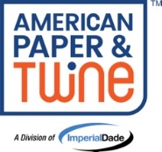 APT Email Signature Guidelines
This is an addendum to the 2025 Imperial Dade email signature guidelines to include templates specific for American Paper & Twine branches. Things to note:
- If you have not already done so, remove the “Please note that my email address has changed to XYZ@imperialdade.com.” message above the signature that we used when we switched from aptcommerce.com email addresses to imperialdade.com addresses.
- Including Department/Function Name is optional. In some instances, adding a department would be redundant, for example if the title is Customer Service Representative and department is Customer Service. But if it makes sense to specify your department or functional team please do so.
- The second phone number is optional. You can include just one phone number if you don’t have two.
- Using a signature for Replies/Forwards is optional. If you choose to use a signature for Replies/Forwards, use the same signature that you use for New Messages.
- Using a signature on mobile devices is optional. If you choose to use a signature on your mobile device, use the same signature that you use for New Messages.
- There is an HR only template provided at the end of the branch templates.

Example APT Signatures:
Example without Department/Function Name
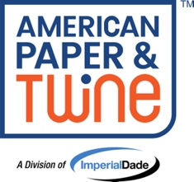 |  | Ruth Bates  Director of Marketing  Imperial Dade – Nashville  O: (615) 350-5222  C: (615) 457-4432  www.ShopAPT.com

Example with Department/Function Name
Terry Day
Product Data and Content Manager
Marketing Department
Imperial Dade – Nashville
O: (615) 390-9050 x2249
www.ShopAPT.com

APT Templates by Branch:

Name
Title
Department/Function Name (Optional)
Imperial Dade – Nashville
O: (555) 555-5555
C: (555) 555-5555
www.ShopAPT.com

Name
Title
Department/Function Name (Optional)
Imperial Dade – Chattanooga
O: (555) 555-5555
C: (555) 555-5555
www.ShopAPT.com

Name
Title
Department/Function Name (Optional)
Imperial Dade – Memphis
O: (555) 555-5555
C: (555) 555-5555
www.ShopAPT.com

Name
Title
Department/Function Name (Optional)
Imperial Dade – Little Rock
O: (555) 555-5555
C: (555) 555-5555
www.ShopAPT.com

Name
Title
Department/Function Name (Optional)
Imperial Dade – Knoxville
O: (555) 555-5555
C: (555) 555-5555
www.ShopAPT.com

Name
Title
Department/Function Name (Optional)
Imperial Dade – Muscle Shoals
O: (555) 555-5555
C: (555) 555-5555
www.ShopAPT.com

Name
Title
Department/Function Name (Optional)
Imperial Dade – Tupelo
O: (555) 555-5555
C: (555) 555-5555
www.ShopAPT.com

APT Template for HR Only:

 |  | Name  Title  Department/Function Name (Optional)  Imperial Dade – Nashville  O: (555) 555-5555  C: (555) 555-5555  Explore Careers with Imperial Dade

